BCRTA Board of Trustees
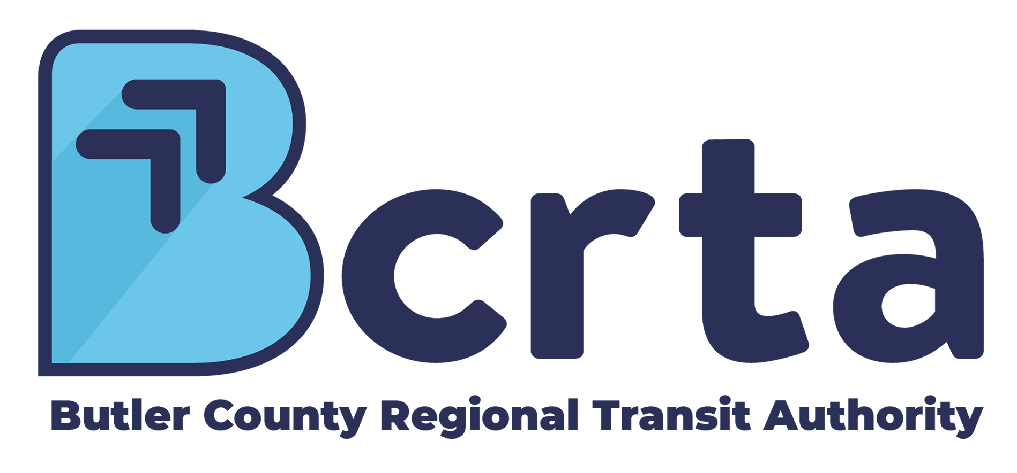

Butler County Regional Transit Authority
Wednesday, January 15, 2025 at 8:00 AM EST to Wednesday, January 15, 2025 at 9:30 AM EST
BCRTA Board Room: 3045 Moser Court, Hamilton, OH 45011

Agenda
- Call to Order & Roll
  - Consideration of Absences
- Consent Agenda
  - Approval of the Agenda
  - Approval of Past Meeting Minutes
- Comments from Citizens
- Treasurer's Report
- Governance
  - Nominating Committee Report
  - Election of Officers
  - Conflict of Interest Forms
- Action Items
  - Resolution 2025-01-01
Presenter: Dee Weidner
Authorizing the filing of (an) SFY 2026 application(s) with the Ohio Department of Transportation by the Butler County Regional Transit Authority (BCRTA) for grants through the US DOT Federal Transit Administration (FTA) and the State of Ohio, as authorized under Federal Transit Laws and State of Ohio laws and executing a contract with the Ohio Department of Transportation upon project approval.
  - Resolution 2025-01-02
Presenter: Meagan Varney
Authorizing the Purchase of Maintenance Parts.
  - Resolution 2025-01-03
Presenter: Shawn Cowan
Removing and Appointing the Transit Alliance of Butler County (TABC) Board of Directors.
  - Resolution 2025-01-04
Presenter: Matthew Dutkevicz
Authorizing the BCRTA Executive Director to Negotiate and Execute a Lease for Office Space.
  - Resolution 2025-01-05
Presenters: Matthew Dutkevicz, Meagan Varney
Amending Resolutions 22-09-02, 23-09-01, and 24-11-07
Authorizing the Butler County Regional Transit Authority
(BCRTA) Executive Director to Execute a Task Order for Parking
Lot Expansion Designs.
- Committee & Staff Reports
  - Ohio-Kentucky-Indiana Regional Council of Governments
Presenters: Chris Lawson, Matthew Dutkevicz
  - Maintenance & Infrastructure
Presenter: Paul Williams
Hamilton "FASST" Project Update
  - Service & Metrics
Presenter: Luke Morgan
  - Marketing & Outreach
Presenter: Shawn Cowan
  - Talent, Benefits, & Recruitment
Presenter: Mary Jane Leveline
  - Procurement
Presenter: Meagan Varney
  - Executive Director's Report
Presenter: Matthew Dutkevicz
- OnBoard 101: https://vimeo.com/774328796
- Conflict: IW / BCRTA / NeoRide
- Executive Session
Pursuant to Ohio Revised Code §121.22 G(1) to consider the employment and compensation of a public employee and
Pursuant to Ohio Revised Code §121.22 G(3) to conference with an attorney for the public body concerning disputes involving the public body that are the subject of pending or imminent court action
- Adjourn

